**The physical address** is the permanent hardware-level address embedded in the Network Interface Card of a device by its manufacturer. IEEE gives a block of addresses to the manufacturer. The manufacturer of the NIC takes an address from the address pool and embeds a unique physical address in each NIC it manufactures. Most Ethernet uses a 48-bit physical address written in the form of 12 hexadecimal numbers where each byte is separated by colons. It is also called Link-layer address or LAN address or MAC address.

Consider four computers are connected to the bus topology Local Area Network. Let us write their physical addresses as a two-digit number. Host A is the sender with physical address 10, and host P is the receiver with physical address 87. Within a LAN, only physical addresses are enough to transfer data. So, the data from host A is encapsulated with destination physical address and source physical address to form a frame at the data link layer. The trailer contains bits for error detection. Note that in a frame, the destination physical address comes before the source physical address. The transmitted frame propagates in both directions.

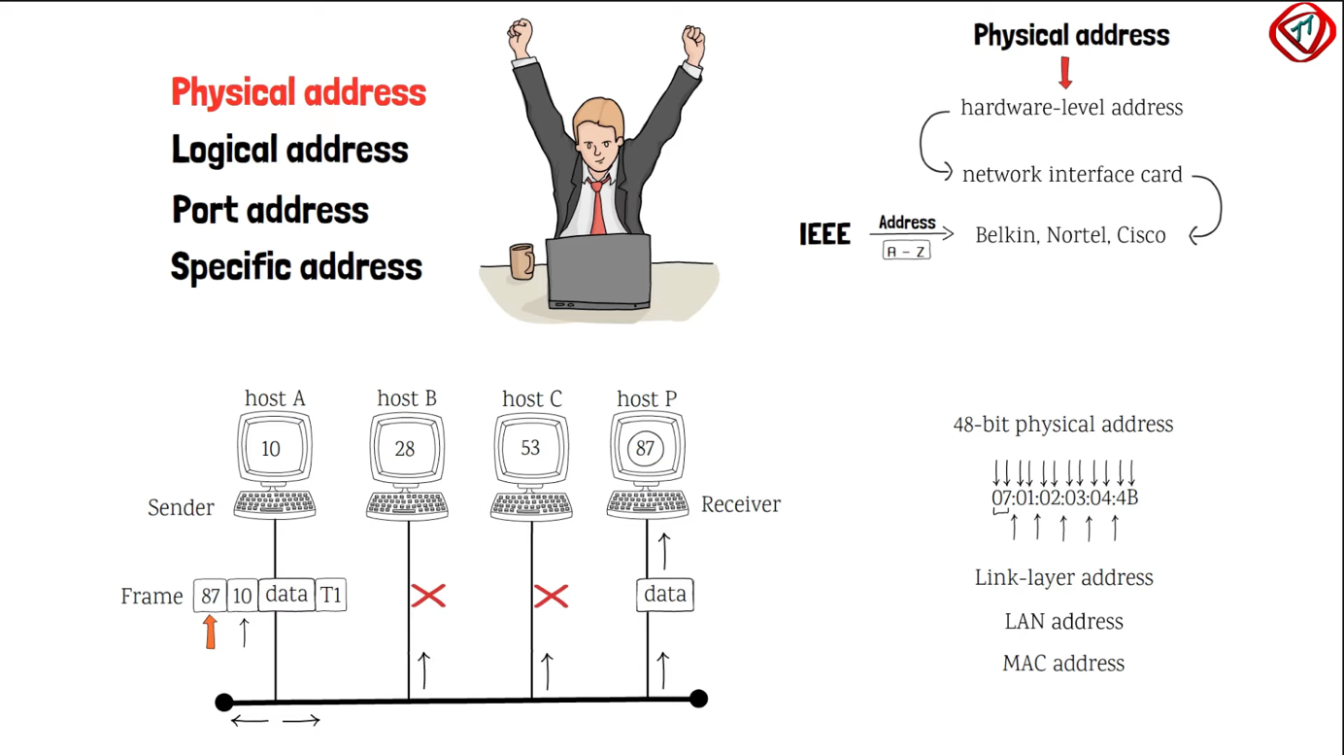

The frame, moved to the left, dies at the cable termination while the one moved to the right is received by all connected hosts. Host B and C drops the frame because the destination address Does not match with their physical addresses. However, host P finds the match. So, it drops the header and trailer from the frame and delivers data to the upper layers. Therefore, the physical address helps to deliver data to the correct destination device within a network.

**Logical address:** Multiple networks link to each other to form an internetwork or the Internet. On the Internet, the devices are identified with an address called a logical address. It is a 32-bit address written in theform of decimal numbers separated with dots. It is called the dotted-decimal notation. Decimal numbers range from 0- 255. No two devices on the Internet can have the same logical address.

Consider a network of three Local Area Networks connected by two routers. Host A is present in LAN 1 and host P is present in LAN 3. Each interface of the device has a pair of logical and physical Address.

**In this example**, the logical address is written in the form of letters, and the physical Address is written as numbers. Now, the host A needs to send data to host P. Here, data will move from one network to another so the sender’s and receiver’s logical addresses A and P are encapsulated with the data to form a packet in the network layer. Note that the logical source address is written before the logical destination address.

Since the destination host is present in different LAN so the data, first, must route to router 1. The network layer finds the logical address of the next-hop, i.e. router 1 – F - using the routing table. Address Resolution Protocol gives its physical address 20. Now the network layer passes this address to the data link layer which encapsulates the

packet with destination physical address 20, and the source physical address 10 to form a frame.All devices in LAN 1 receives this frame but only router 1 accepts it, others drop it. Router 1 decapsulates the frame and reads the logical destination address P. Since it is different from its logical address, the router knows the packet needs to be forwarded.

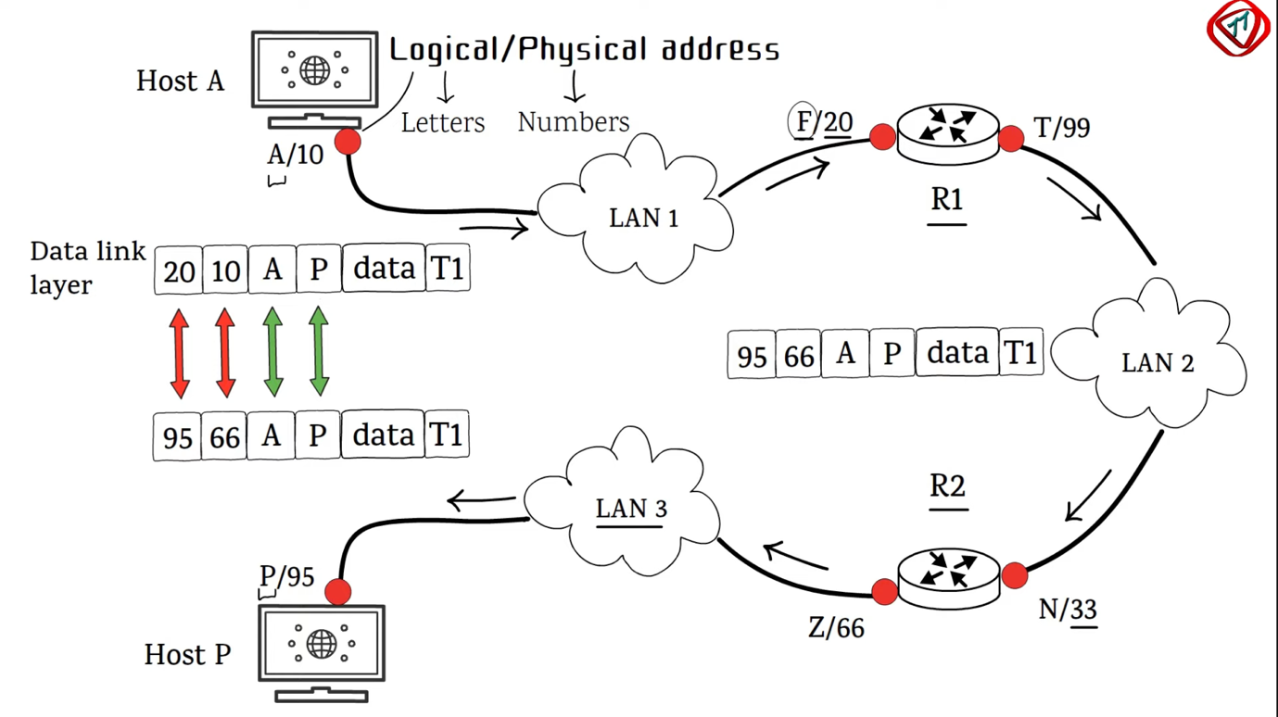

The router finds the logical address of the next-hop, i.e. Router 2, with its routing table

and Address Resolution Protocol provides the physical address of router 2. A frame with physical destination address 33 and physical source address 99 is created andtransmitted in LAN 2. Router 2 accepts the frame, decapsulates it, checks the logical destination address P and repeats the same scenario. Finally, the frame with physical destination address 95 and physical source address 66 is transmitted. Host P accepts the frame, decapsulates it, and sends data to the upper layers. Note that with every hop, the physical address in the frame changes. On the other hand, the logical addresses remain the same. The logical address should remain the same, otherwise, the packets will be lost in the network. Hence, the logical address is used to deliver data across networks.